

**MENTAL HEALTH & LEARNING DISABILITIES**

**Team Leader Induction Workbook**



|  |  |
| --- | --- |
| **Name:** |  |
| **Job Title:** |  |
| **Date of Commencement in Team Leader role:** |  |
| **Induction Period 6 months (start and end dates):** |  |
| **Mentor/Buddy:** |  |
| **HOP/Manager with ongoing responsibility:** |  |

TABLE OF CONTENTS

Introduction 3

Gibbs reflection model 5

Section 1 – Short term objectives 7

Section 2 – Medium to long term objectives 8

Section 3 – Longer term objectives 13

Compassionate Leadership 14

Useful links 15



# WELCOME TO THE TEAM LEADERS WORKBOOK

The aim of this workbook is to ensure all Team Leaders’ are in possession of the knowledge of their new work environment, the people they lead and the work and systems they manage and are accountable for.

**Whether you are a Team Leader in Nursing or in Administration you can use this workbook. Note that some references or objectives may not be applicable to all roles.**

Our aim is for our Team Leaders to:

* Feel better supported in their role
* Be compassionate in supporting their team members to thrive
* Have the right personal and professional development
* Help retain and develop people in workforce and reduce sickness absence

On starting in your role you will be assigned a mentor/buddy of this induction. It is, however, your responsibility to gain as much as you can from your induction period, attend a MH&LD Staff Connect day and maintain this record. If you are new to the organisation your Manager will arrange for you to also attend the Corporate Induction programme.

It is recommended that you attend a MH&LD Staff Connect day If you are being internally promoted to a managerial role or moving from another division.

This workbook should be introduced to you and discussed with your Head of Dept/Mentor.

**Section 1** recommended as short-term objectives

**Section 2** recommended completion by the end of your induction period (6 months)

## **Section 3** addresses additional learning needs that you may have and which need to be addressed as a priority. You should also make a date for your first Personal Development Review with your Manager.

The workbook has space for comments so that you can comment/reflect where appropriate. For example, this may include issues that need to be looked at in more depth; future learning requirements; areas of concern with systems encountered or deficits that need bringing to the attention of others (e.g. your manager or team members). Discussion at the end of each section, with your mentor/buddy, will ensure a two-way process of feedback.

It’s recommended you use a reflection model such as ‘Gibb’s’ which you may already be familiar with. We’ve added it in this booklet as a reference and you can use the blank one to print out if you wish.



|  |  |  |
| --- | --- | --- |
| **Description** | **Feelings** | **Evaluation** |
| Using specific and relevant detail, give a concise description of your experience. (i.e. what you are reflecting on).  This part is not analytical, it is descriptive, it describes an experience. | Think about the following questions that you think are relevant to the experience:   * How did you feel and what did you think prior to the experience? * How did you feel and what did you think during the experience? * How did you react during the experience? * How did you feel and what did you think after the experience?   This part is not analytical, it is descriptive, it describes personal feeling, thoughts and actions (reactions) | Address any of the following you think are relevant to the experience   * What went well during the experience (what worked) * What went badly during the experience (What didn’t work)   Note – important to balance positive and negative evenly as a minimum.   * How did the experience end? Was the experience complete (was there a resolution or incomplete   This part is not analytical, it makes positive and / or negative judgements about an experience  If a lot of different things happened during the experience, focus on one or two, try to choose the things that are most important, most relevant or most representative of the experience |
| **Analysis** | **Conclusion** | **Action Plan** |
| Do any of the following you think are relevant   * Reconsider the things that went well and badly and explain why you think they went well and/or badly * Reconsider the things that went well or/and badly and explain what you think this lead to * Think about what could have been done differently. * Think about how positive action could be further improved   Think about your contribution to the experience and say how useful it was and why it was useful.  If you were unable to contribute to the experience say why?  Think about other people present during the experience and try to assess whether their reactions were similar or different to yours. Try to include why they were different or the same if this is something you noticed. This part is analytical, it does not describe, it tries to explain the causes and consequences of things that happened, it asks questions like why? So what? And what if? | Reconsider the experience and answer the following questions that you think are **relevant**:   * What should or could I have done differently? * What stopped me from doing this? * What did I learn about myself during the experience (positive and/or negative)? * What did I learn about my current knowledge or level of practice (strengths and weaknesses)? * Did the experience achieve any of my learning goals or meet any of my required competencies?   This part sums up what you learnt from the experience.  Try to be specific about what you learnt or realised about yourself, give specific details (avoid making general statement like “I didn’t have the adequate knowledge” | Answer any of the following questions that you think are **relevant** to making a plan:   * What do I need to do in order to be better prepared to face this experience in future? * Even if the experience was positive and I did well, in which areas can I improve? * What are the priority areas that need to be developed? * What specific steps do I need to take in order to achieve these improvements?   This part is not analytical, it states actions designed to improve knowledge, ability, experience etc. you can include the justification for, and value of actions in the action plan (i.e. why you plan to do something)  Try to be specific about what you plan to do (e.g. state specific training you may need to undergo, books or policy guidelines you may need to read, resources you may need to use and become proficient in etc. |

# Section 1 Short term objectives

Reflect on your initial experiences and observations? What is your focus now for your development? Spend some time making notes in order to reflect and prioritise your learning and development and consider what else you might need.

|  |  |
| --- | --- |
| **Team Leader priorities** | **Comments and development areas** |
| **Local to your area:**  Fire checks/procedures - Ward or dept  Getting to know your ward/area and how things work  Telephone numbers  Weekly/monthly planner  Who to contact  Key list |  |
| **Systems:**  E-roster, ESR,  Datix, Roster publication deadlines,  Annual leave |  |
| **Risk and Health & Safety:**  Environmental risk assessment,  infection control |  |
| **Personal needs:** Laptop/phone *What other resources, if any do I need?*  **Wellness, Work and Us Service** – *Referrals and how can this service benefit me as a new Manager? e.g. Coaching* |  |
| **Leadership:**  What is the Meeting/reporting structure?  Getting familiar with Sickness reporting  Getting to know your staff – *have you met everyone? What is your sense of how the team operates and connects?* |  |

# section 2

## Short-Medium term objectives – first 6 months

| **Team Leader priorities** | **Comments and development areas** |
| --- | --- |
| **Shadow/network meetings with experienced Managers** e.g.   * Putting Things Right (PTR) * Quality & Safety (QSE) * Operational Leaders Meeting (OLM) * Finance * Training & Development * People and Culture Group * Any other relevant meeting |  |
| **Patient/carer complaints processes and handling**  PTR, dealt with on the spot,  What’s your role now as a leader? |  |
| **Weekly/monthly Audits/Q&S**  Have they been done/delegated etc |  |
| **Occupational Health/Workforce**  Who are your contacts and support  Wellness Action Plans |  |
| **Trauma Risk Management (TRIM)**  How and when to make a referral |  |
| **Staff Personal files**  Organising them and keeping them up to date |  |
| **Finance/Budgets**  Who is your Finance contact and what are your Finance objectives? |  |
| **Knowing your policies**  What is your learning from Workforce policies. Where do you require further learning or support? |  |
| **Booking Bank/agency staff**  How do you do it/Get authorised. What have you already tried? |  |
| **New Staff and Leavers**  Local induction/Orientation/Staff Connect  Nurse bank internal application  **Establishment control** – getting familiar processes for your recruitment needs  **Exit Interviews**  All staff to be offered an exit interview on receipt of their resignation. Get to know the procedure (see Betsinet)  **Retiring staff**  All staff of retiring age to be made aware of relevant policies and procedures, and of any available information sessions |  |
| **Ward Accreditation (if applicable) – refer to Ward Managers toolkit available on ward accreditation pages on Betsinet**  **Environmental** – infection control, clean and well organized, patient friendly  **Quality Improvement** – patient feedback, staff feedback  **MDT Communication** – patient flow, safety, discharge  **Well Lead teams** – leadership, culture, governance, training, staffing |  |
| **Supervision** – what’s your role, what further development do you require (speak to your Buddy).  Be clear about the differences between Clinical Supervision and Management Supervision.  What obstacles, if any, are getting in the way? How can they be overcome?  Wellness Action Plans – ensuring yours and your team members are completed and reviewed regularly (approx. 6 monthly).  Stay Conversations - as part of supervision, discuss with staff their thoughts in relation to making their work as good as it can be. |  |
| **Respect & Resolution** [WP5 - All Wales Respect and Resolution Policy - V1.pdf (sharepoint.com)](https://nhswales365.sharepoint.com/sites/BCU_Intranet_POLCS/QMS/WP5%20-%20All%20Wales%20Respect%20and%20Resolution%20Policy%20-%20V1.pdf)  Think of some examples of when you have used/might use informal approaches and how this has or will benefit your team.  When might a formal process be necessary?  What’s your role in helping staff to feel safe to express their views? What might you find a challenge and how can you prepare for it? |  |
| **PADR**  How important to staff and quality is an annual review; what’s your role in supporting this?  What obstacles, if any, are getting in the way? How can they be overcome? Can you delegate any to experienced staff? |  |
| **Your Leadership Impact**  Some things to consider…  What is your approach and how is it impacting on your team members? How would you like to develop further?  Give an example of a situation you have observed – what were the positive aspects? What were the negative aspects? How would you approach a similar situation next time?  Describe how you are aligning decisions to your service objectives, values and policies  *What’s your initial leadership impact – how are staff experiencing you?*  *How do you adapt your leadership style to accommodate your colleagues individualities?*  *How does your leadership affect the service user experience?*  *How are you fostering a culture of compassionate care in your team? (see final page for question prompts)?* |  |

# section 3

## Longer term objectives – 6 months and beyond

|  |  |
| --- | --- |
| **Team Leader Priorities** | **Reflections and Comments** |
| Coaching – arrange coaching sessions with a qualified coach |  |
| ASiM (A Step into Management) in-house programme |  |
| OTHER e.g.  360 Feedback Health Care Leadership Model  ILM Leadership & Management programme  ILM Coaching & Mentoring programme |  |

## 

## **Compassionate Leadership**

Leading with compassion and humanity

We all know that respectful, open relationships are at the heart of quality care, and the starting point is for us to reflect on ourselves as leaders so that we can be in a good place to support our patients, clients, and our colleagues. For our patients and carers, how care is delivered is often as important as the nature of the treatment itself.

Compassionate care has always been considered fundamental to practice. The significant role leadership plays in enhancing experiences of services by promoting compassionate, person-centered care cannot be underestimated. Person centered care is about valuing each individual patient, relative or colleague. It’s about establishing and developing effective relationships and ensuring that all people are valued, feel safe and are cared for with dignity, experience, courtesy, respect and kindness.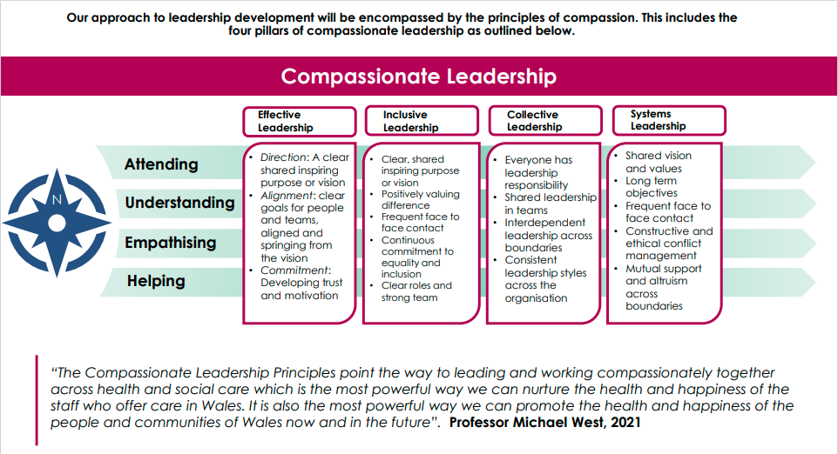

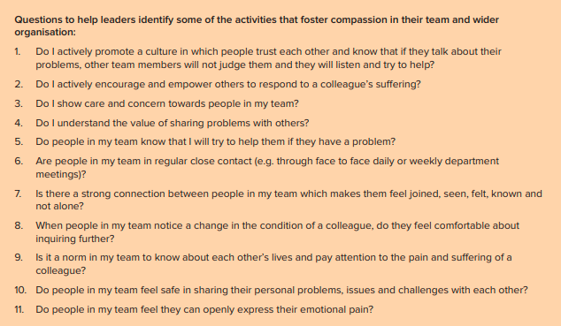

(Roffey Park Institute 2016)

**Useful Links**

Manager’s toolkit link: [Manager's Toolkit (sharepoint.com)](https://nhswales365.sharepoint.com/sites/BCU_Intranet/SitePages/Manager's-Toolkit.aspx)

Sign-up link for Gwella Leadership portal: [Welcome! - Gwella HEIW Leadership Portal for Wales](https://leadershipportal.heiw.wales/?_gl=1*103vng9*_ga*OTE0NDE1Nzg2LjE2NTc3MTEwMTM.*_ga_90HCJ952MP*MTY5ODQxNDIzMC4xOC4wLjE2OTg0MTQyMzAuMC4wLjA.)

Access the King’s fund for research on leadership in Health Care: [The King's Fund | health policy, NHS leadership, events (kingsfund.org.uk)](https://www.kingsfund.org.uk/)

Recommended reading: Compassionate Leadership: Sustaining Wisdom, Humanity and Presence in Health and Social Care *Michael A. West, Swirling Leaf Press*

*Produced by MHLD Wellness, Work and Us 2024*