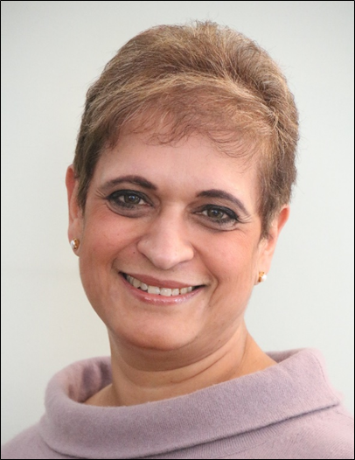
Professor Kamila Hawthorne has been a GP in South Wales for 25 years, having originally qualified from Oxford University in 1984, and completed her GP training in Nottingham in 1988. She is an academic medical educator, newly appointed as Head of the Graduate Entry Medicine Programme at Swansea University. She is also a past RCGP Vice Chair (Professional Development), a Nationally Elected Member of RCGP Council, an MRCGP Examiner and a Bevan Commissioner.
Professor Hawthorne has a real interest in the social accountability of medical schools, and believes that we should be training excellent, caring and inclusive clinicians who understand people, and the communities in which we all live. She is also believes contemporary curricula should include Leadership and Management skills, Digital and Communications Technology, and ‘One Health in a global community’. She has expertise in designing ‘community facing’ medical curricula.
Her research and clinical working interests have been in health inequalities and access to health services, (her MD was based on working with BAME groups with Type 2 diabetes in Nottingham, Manchester and Cardiff). With wide experience of general practice and running community projects in diabetes and heart disease, she has been named ‘GP of the Year’ twice for her work with BME communities and with patients and was awarded an MBE in the Queen’s New Year Honours List 2017 for services to General Practice.

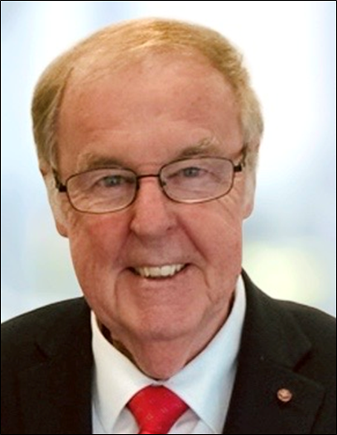
Prof Trevor M Jones CBE FMedSci PhD DSc Hon FRCP FBPhS FRSM FRSC FLSW is a visiting professor at King’s College, London and holds honorary degrees and Gold Medals from 7 universities. He is a Director of the life science investment company Arix Bioscience plc and the Oxford based Drug Discovery Company, e-Therapeutics plc. He was formerly a Director of Allergan Inc. (USA), R&D Director of The Wellcome Foundation and Director General of the ABPI.
His links to Wales include being a member of the Wales Government, Bevan Commission on Health, a Fellow of the Learned Society of Wales, Director of Respiratory Innovation Wales Ltg,a former Director of the Welsh Merlin, Excalibur and Arthurian biotech Venture Funds and Chairman of the international Clinical Research Company Simbec-Orion Ltd, headquartered in Merthyr Tydfil.
He was a founder member of the Medicines for Malaria Venture (MMV), Chair of the UK Government Advisory Group on Genetics Research, a member of the Medicines Commission Regulatory Agency, a Commissioner at The World Health Organisation, WHO and the British Singapore Trade Council (SBBC).
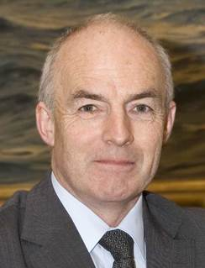
Louis Lillywhite retired as Surgeon General of the UK Armed Forces in 2010. His 42-year career in the Army included medical appointments as a consultant occupational physician, operational deployments, and command and staff appointments in the Ministry of Defence and in various army and NATO Headquarters. During his service he reformed and commanded the Parachute Medical unit; led on two major change programmes, including closing and integrating two military hospitals into the NHS; was the medical commander within the 1st UK Armoured Division during the first Gulf War; and CE of British Forces Health Service in Germany (comprising a partnership of Guys & St Thomas’, German Hospitals, military primary care, and a NGO community health service). As Surgeon General during the first half of the Afghanistan Campaign he led on the development of various clinical initiatives that led to the service being judged as “Exemplary” by the then Healthcare Commission. His awards include honorary Fellowship of the Royal College of Physicians of Glasgow and of the Royal College of General Practitioners and was the first foreign medical individual to be awarded the US Office of the Secretary of State for Defence medal for exceptional public service.
After retirement he became for six years Chief Medical Officer of St John Ambulance as well as working with Chatham House addressing the interface between health and conflict. His area of interest expanded into the global aspects of infectious diseases with his co-option onto the WHO post Ebola Review Committee of the International Health Regulations and is currently an advisor on a Neglected Tropical Disease programme in East Africa and Asia. He has co-authored publications, and organized Round Tables, on civilian casualties of the Syrian Conflict; on civ-mil relations; on infectious disease impacts on international travel; international occupational health issues; and global health aspects for the Munich Security Conference for which he led on the development of the Global Health Security Track. He continues to be involved in research and work on safeguarding health in areas of conflict and on civ-mil relations. Although still retired from the Army he was 4 years ago appointed as Master General of the Army Medical Services which is an advisory appointment. He is a member of the Tribunal Appeal Service, hearing appeals in respect of health related benefits such as Employment Support Allowance, Disability Living Allowance and Personal Independent Payment in Wales and South West England. He is a member of the Bevan Commission for Wales, a Trustee of the Medical Society of London and of the Parachute Regiment and Airborne Forces Charity and a member of various independent advisory bodies such as the Imperial College Centre for Blast Injury Research and Welsh Government R&D External Advisory Group.

