**Exercise 1**

In pairs or small group exercise / Length of Exercise:

**Importance of core needs – why are they not met; how can leaders meet them?**

1. Reflect on the core needs, why are they not being met in health and social care?
2. How can you as leaders individually and collectively (with each other and other leaders across the system) better meet the core needs of staff?

|  |
| --- |
|  |

**Exercise 2**

Group and individually / Length of Exercise:

**Eight areas of action and how leaders can personally plan to commit to them**

1. Reflect on each of the eight areas of action, what can you do?

|  |
| --- |
|  |

1. Action planning (individually) on your commitments as a compassionate leader in relation to the eight areas.

**Exercise 3**

Group Exercise / Length of Exercise:

**Mediation/Mindfulness - Input on self-compassion**

Capture your thoughts and reflections

|  |
| --- |
|  |

**Exercise 4**

Individual and Pairs Exercise / Length of Exercise:

**Four areas of self-compassion**

1. How are you effective in each of the four areas of self-compassion?
2. What can you do to strengthen each area?

|  |
| --- |
|  |

**Exercise 5**

Pair Exercise / Length of Exercise:

**Enabling recovery and encouraging awareness**

How to better enable your own recovery and encourage awareness of recovery in your teams?

|  |
| --- |
|  |

**Exercise 6**

Pair Exercise / Length of Exercise:

**Implementing the six ways to wellbeing**

To what extent do you implement the six ways to well-being and how can you improve these and raise awareness in your teams?

|  |
| --- |
|  |

**Exercise 7**

Pair Exercise / Length of Exercise:

**Self-Compassion**

|  |  |
| --- | --- |
| Complete the self-compassion questionnaire | <https://self-compassion.org/self-compassion-test/> |

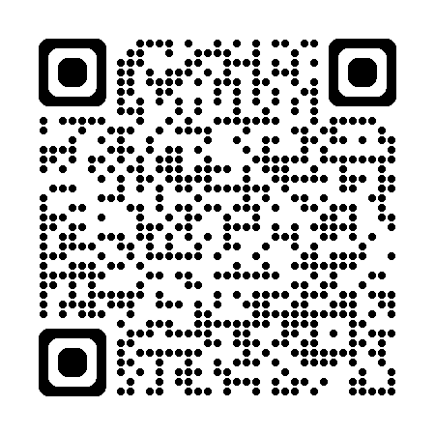

**Exercise 8**

Group Exercise/Length of Exercise

Capture your thoughts from the clip.

|  |
| --- |
|  |

**Exercise 9**

Individual Exercise/Length of Exercise

***How to apply self-compassion in my leadership***

Reflect and set yourself 4 or 5 goals.

|  |  |
| --- | --- |
| **1.** |  |
| **2.** |  |
| **3.** |  |
| **4.** |  |
| **5.** |  |

**Exercise 10**

Individual Exercise/Length of Exercise

**Action Planning**

|  |
| --- |
|  |