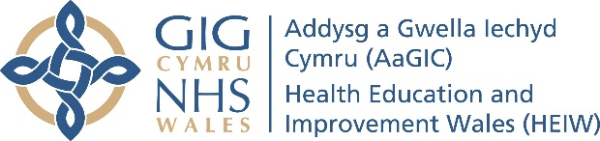

3D Project Examples 2020-21
Promoting/initiating weight reduction at flu and Covid-19 immunisation.
Introducing a primary ureteroscopy service for management of patients attending the emergency department in Wrexham Maelor Hospital with renal colic secondary to ureteric stones.
Reducing radiation dose while taking intra-oral radiographs in the North Wales Community Dental service.
Setting up a Cluster Asthma Diagnostic Hub
Developing a sustainable Pharmacy Service in Wrexham Maelor Emergency Department.
Improving telemedicine consultations within the GPOOH setting.
Improving the transfer of patients between primary care, community hospitals and secondary care.
Introducing virtual reality (VR) as a distraction for children undergoing procedures.
Antimicrobial stewardship in primary care.
Integrating the Pharmacy team into the Frail and Older Peoples Falls Service at the Princess of Wales Hospital, CTMUHB.
Transforming outpatient care in general surgery
Optimising pathways to facilitate outpatient virtual consultations for benign urological diseases.
Developing an oral health care referral pathway for people affected by stroke in Aneurin Bevan University Health Board.
Establishing PROMS/PREMS measurement in skin cancer management as routine practice.
Developing an Oncogeriatric service for south west Wales Cancer Centre.
Developing a GP led Same Day Emergency Care Service in Prince Philip Hospital, Llanelli.
Developing an all Wales policy for prescribing teratogenic retinoid drugs to female patients.

3D Project Examples 2021-22
Developing the role of an independent prescribing Pharmacist within a Cluster Unscheduled Care Hub.
Tackling deadly delays in the urgent suspected cancer pathway in oral and maxillofacial surgery.
Developing a primary care Diabetes support network.
Improving the diagnosis of congenital cytomegalovirus (cCMV) infection in Wales.
Swansea Bay UHB Long Covid service implementation.
Developing the role of the arts in healthcare.
Creating an e-learning module for paediatric prescribing.
Improving awareness of and access to Mental Health services in the community.
Developing the role of 3D imaging in surgical planning for implant based breast reconstruction and patient satisfaction
To assess the uptake of dental attendance of children participating in the Designed to Smile (D2S) oral health improvement programme who have been identified as having dental decay and to develop a care pathway to ensure access to dental care is local and timely.
Developing a monthly prescribing safety bulletin for junior doctors in Withybush General Hospital.
Improving the management of acute and recurrent UTI infections in the Afan Cluster.

